Test Case - how to design a test case

Before design a test case you should know the following questions

What you want to test
How will you cover your requirements or user stories?
Will you conduct functional tests only, or are you testing other aspects?

How you will test
What are the steps to test a functionality?
What test data will you use?
What is needed to test
What are the required preconditions to execute a test?

Where you want to test
What environments are you going to run the test on?
Do you need any particular hardware to run the tests on?

When you want to test
What is the importance or priority of each test?
In which stages of development will you run each test?

Test cases (or just Cases) are the items in TestRail used to design and document your testing strategy for your application. These cases are managed on the Test Cases page.
Each test case has a unique ID, usually identified with a C prefix in the TestRail UI. This unique ID can be used to reference the test case in other test cases, comments, or via the API, and it cannot be changed.

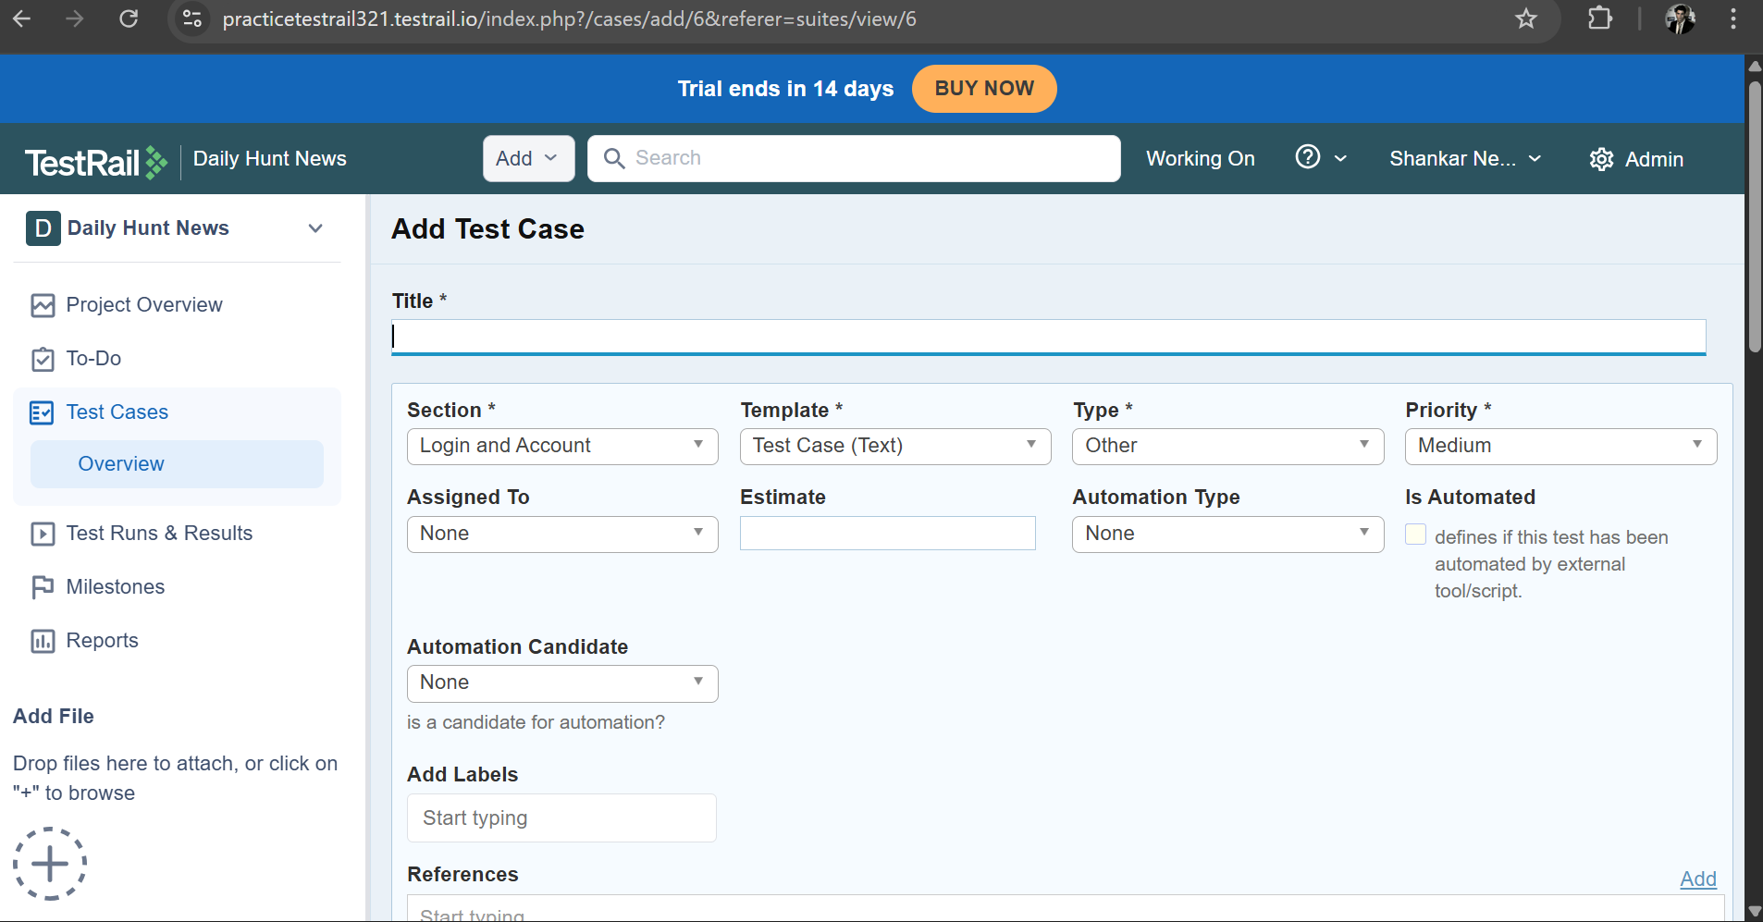

By clicking on the test case which is on the left side bar and then add new test case.
Title: Write the title of the test case like “validate the login page with valid credentials”
Select section and subsection, template
Type: What type is this test case belongs to like automation, acceptance, performance, manual, functional
Priority: Give priority based on the test case like high, medium, low. It tells which should be executed first
Assigned to: Assign a test case to a particular user
Estimated: Enter estimated time is required to complete the test case
References: It is used to link up the test case with user stories in other platforms like “Jira”
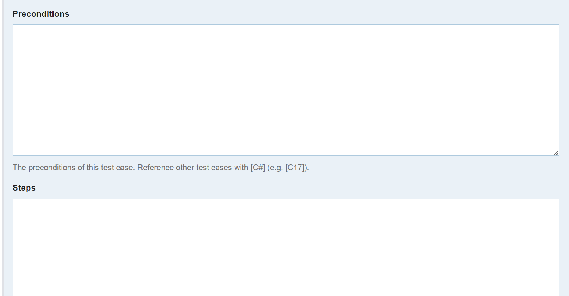

Preconditions: Preconditions or Prerequisites are the necessary steps to do before executing a test case
Example – let Say “validate the login page with valid credentials” is a test case then
Preconditions are “The user must be the installed the app or software”, “The user is already an account in the app or its database”.

Steps: These are the steps that describe about how to execute the test case in a procedural manner.
Example: let Say “validate the login page with valid credentials” is a test case. Then the steps to execute this test case are –
Step-1: Enter username as specified
Step-2: Enter password as specified
Step-3: Click on login button
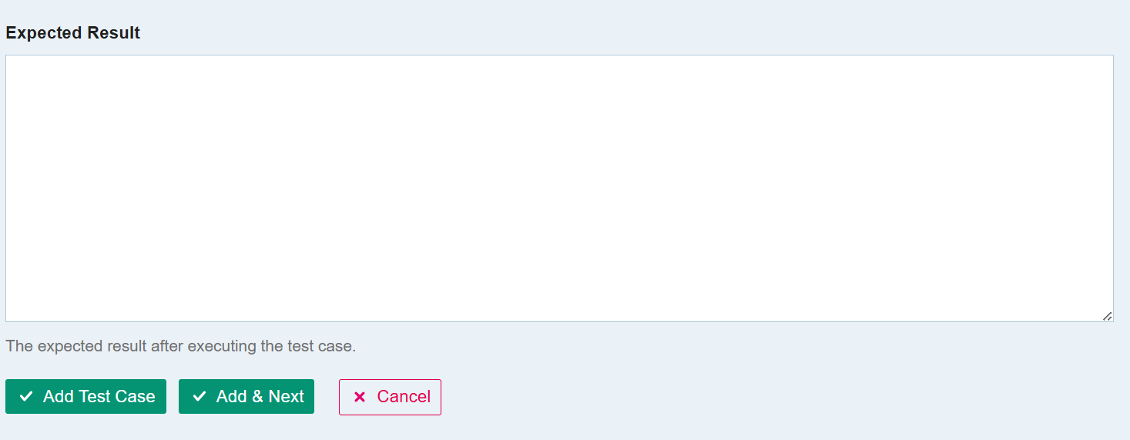
Expected Result: It tells the actual output of the test case. After executing the test case we are going to compare the executed result with this expected or actual result for validating the test case is passed or failed.

